**Classroom Activity: Passing a Function as a Prop**

In this example, the parent component passes a function as a prop to the child component. The child component calls the function when a button is clicked.

**Code:**

File Name: src/App.js

import React from 'react';

// Parent component

function App() {

    const printNote = (content) => {

      console.log(content);

    };

    return (

      <Note

        id="1"

        title="This is the title"

        content="Blog about props"

        onClickNote={printNote}

      />

    );

  }

  // Child component

  function Note(props) {

    return (

      <div>

        <h1>{props.title}</h1>

        <p>{props.content}</p>

        <button onClick={() => props.onClickNote(props.content)}>

          Print Note

        </button>

      </div>

    );

  }

export default App;

**OUTPUT:**

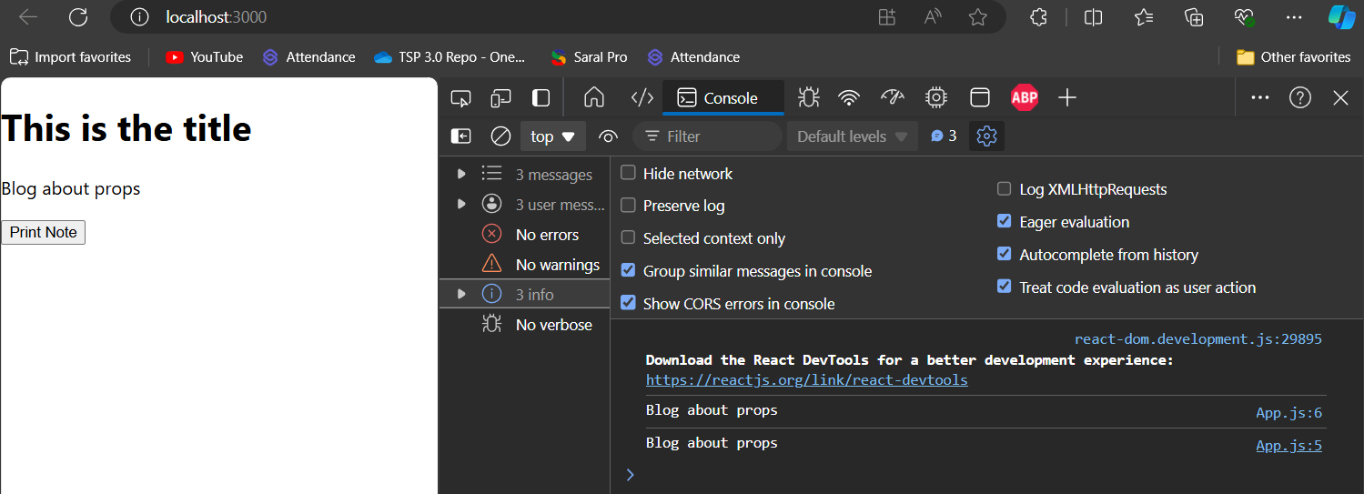

Figure: Output Screenshot

**Execution Steps:**

* Write the above code
* Go to VS Code terminal
* Execute following command to run the program: npm start
* This will open your default browser and navigate to http://localhost:3000, where you will see your new React application running.